**Kol Simcha Torah Gazette**

**For parsha korach 5785**

Volume 9 Issue 39 (Whole #454) 2 Tammuz 5785/ June 28, 2025

**Printed L’illuy nishmas Nechama bas R’ Noach, a”h**

For a free subscription, please forward your request to [***keren18@juno.com***](mailto:keren18@juno.com)

***Past emails can be found on the website ShabbosStories.com under Brooklyn Torah Gazette***

**Counting the Miracles in Be’er Sheva After Iran Targets Soroka Hospital**

**By Bruria Efune**

‘If missile hit ten hours earlier, we could have had massive casualty event’

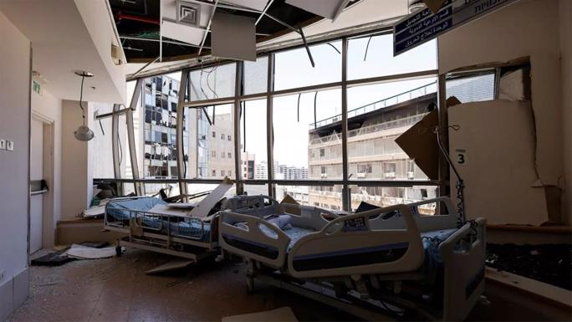

**Damage from Iran's attack on the Soroka Medical Center in Be'er Sheva this morning. (Photo Credit** *Via X)*

BE’ER SHEVA, Israel—On a typical day, Rabbi Yossi Litzman, goes from room to room at Soroka Medical Center to speak with patients. He asks how they’re doing, lends a listening ear, and shares words of comfort and support. He also offers to help the men put on *tefillin*, and his wife, Shoshi, helps the women light Shabbat candles on Fridays.

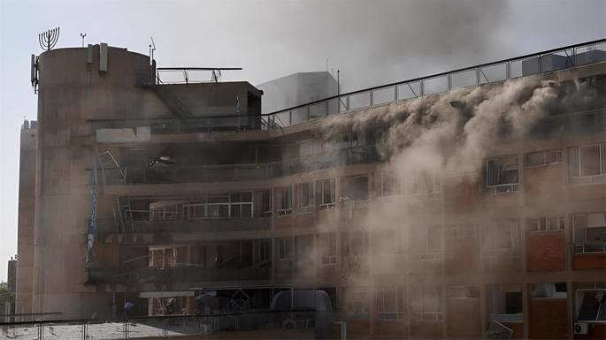

**"If the missile had hit even ten hours earlier, we could have had a massive casualty event. It would have been unimaginable horror." (**Photo Credit **-***Via X)*

The Litzmans direct Chabad-Lubavitch at Soroka Hospital in the desert city of Be’er Sheva. It’s a major hospital in Israel, the only large one in Israel’s entire southern half, and serves a population of about 1 million people. The Litzmans, together with fellow Chabad of Soroka emissaries Rabbi Shmulik and Nechama Friman, are constantly busy bringing love and care to those who need it most.

This morning, when Rabbi Litzman arrived at the hospital, everything was different. Soroka had suffered a direct hit from an Iranian ballistic missile. Patients flocked to the rabbi, eager to share their miraculous stories, don [*tefillin*](https://www.chabad.org/library/article_cdo/aid/1918251/jewish/What-Are-Tefillin.htm), or do another mitzvah.

“We don’t have a bomb shelter in our home,” explains Shoshi Litzman. “So we had to get all of our children out of the house and across the street to the public bomb shelter fast. We arrived right in time to hear the very loud explosion. We knew that something right nearby was hit.”

It was Soroka, just a few hundred feet away. As soon as the Home Front Command notice was given that it was safe to leave shelter, Rabbi Litzman rushed over.

At first glance, the outlook was bleak. Shrapnel was everywhere, and an entire building appeared to be destroyed. Black smoke rose into the sky. The missile had impacted the surgical building, where patients in recovery were mostly immobile, incapable of getting up on their own to evacuate for missile alerts. There weren’t enough staff to bring them all to safety, either.

But upon further investigation, he learned that “The hospital had been evacuating the patients in the older buildings, ward by ward. Some were moved to more secure buildings, and others were discharged. The top floors of this building were just evacuated yesterday. If the missile had hit even ten hours earlier, we could have had a massive casualty event. It would have been unimaginable horror.”

The rabbi shuddered before continuing, “And if it landed just a few feet in the other direction, it would have hit a building where new mothers are in labor, and where most didn’t manage to reach a shelter in time.”

**‘My Head was Spared’**

At the hospital grounds, Rabbi Litzman quickly faced a line of medical patients and staff who wanted to give thanks to G‑d. “They all spoke of open miracles. Every single person had a story—how they managed to get to shelter just in time, or how their room got sprayed with shrapnel, but they were left unharmed. They felt [G‑d](https://www.chabad.org/library/article_cdo/aid/433240/jewish/God.htm) with them,” the rabbi reports.

While the area of the main impact was empty, the damage is widespread, and most patients have been transferred to a different hospital. The buildings’ foundations are also damaged, and initially there were concerns of hazardous materials leaking, though emergency services later determined that there was no danger.

Despite the destruction and initial shock, the mood today has been one of awe.

“A week ago, I met Oren, a new patient at the hospital,” says Litzman. “We spoke for a while, and then I asked him if he wanted to put on *tefillin* and pray. He said he wasn’t interested—it’s something he’s not done since his *bar mitzvah*. He later changed his mind, and I’ve helped him do it again every day this week.”

Oren kept a poker face, and Litzman wasn’t sure whether he was agreeing to the *tefillin*simply as a favor to the rabbi or whether it meant something higher to him. Today he found out.

“He said to me, “Rabbi, I put the *tefillin* on my head every day, and that’s why today my head was spared!’” recounts Litzman.

Oren told the rabbi that he had been stuck in his bed, unable to go to the bomb shelter on his own. When the missile impacted, the window in his room popped off the wall—but miraculously didn’t shatter.

“The glass should have catapulted into my head,” Oren exclaimed. “The merit of the *tefillin*protected me!”

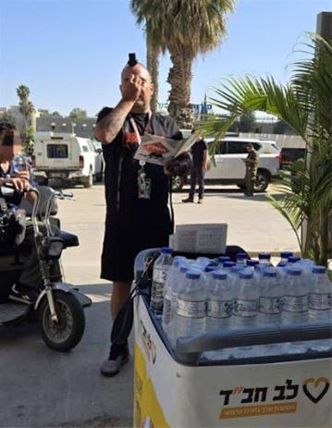

**Laying tefillin outside Soroka Medical Center after the attack.**

Another patient told Rabbi Litzman that an iron door was blown off into the room where he and others were sheltering, but somehow none of them were hurt. Yet another related how there was no shelter in her area, so she and other patients crowded in a corridor, and then watched as the room they were in moments earlier was completely destroyed.

Out of the thousands at the site, five people sustained light injuries from the attack.

“From morning until night, I listened to each person share their own miracle story, and helped them give thanks to G‑d,” says Litzman. “The faith amongst everyone I spoke to was powerful—a true testament to our people.”

Be’er Sheva’s mayor, Ruvik Danilovich, arrived at the scene and captured the spirit of the Jewish people in his words, “We are at war with a country that wants to destroy us. We have prepared in advance for every scenario—and we will defeat our enemies! They will not overwhelm us. We have already gone through many rounds [of war] and difficult military campaigns. This is a war for the very existence of the Jewish people in our land. In the name of G‑d, we will do it, we will succeed and we will win!”

Rabbi Litzman agrees, “The Rebbe [Rabbi Menachem M. Schneerson, of righteous memory] told us over and over again—this is the Land upon which [G‑d places His eyes](https://www.chabad.org/library/bible_cdo/aid/9975/jewish/Chapter-11.htm) ‘from the beginning of the year to to the end of the year.’ Day and night, with no rest. We’ve grown used to the miracles here. We know that we are alive today because G‑d is closely guarding us, and we know that we will thrive tomorrow, because He is leading us into miraculous times.”

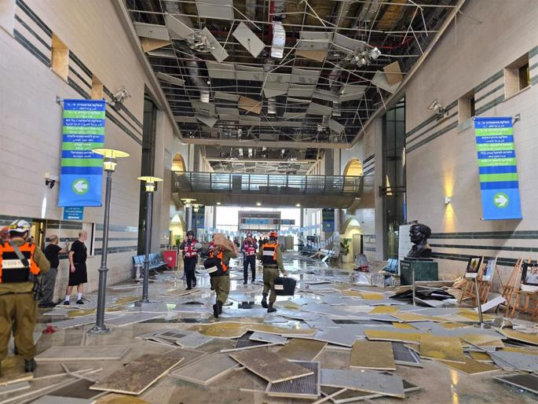

**Soroka Medical Center is the largest hospital in Israel's south.**

*Reprinted from the current website of Chabad.Org*

**Rav Avigdor Miller on**

**Should I Buy a House**

**in Eretz Yisroel?**

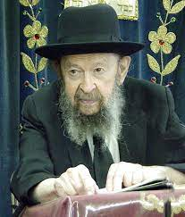

And the answer is that you should buy a house in the place where you’re making a living. To go to Eretz Yisroel and become a schnorrer doesn’t pay. No, no. It doesn’t pay. You must make a living. And therefore, whether you buy a house or rent a house, make sure that you’re in a place where you can make a living.

And you should always make sure to find a frum neighborhood. It’s very important. Sevivah, environment, is everything. Not only for your children but for you as well. People who live around a Yeshiva are different than people who live someplace else. You see tzitzis out. Everyone is wearing a black hat. Shabbos is a different kind of Shabbos. It’s a different kind of life. It’s very important to live in a frum neighborhood. And even though sometimes it may be more expensive to live there, it’s worth it. I cannot overemphasize that. A frum neighborhood is most important.

*Reprinted from a recent email of Toras Avigdor based on a Thursday night lecture (February 1999)*

**The Unique Mission in**

**Life For Every Jew**

**From the Teachings of the Lubavitcher Rebbe**

**Rabbi Menachem Mendel Schneerson, Zt”l**



This week's Torah portion, Korach, tells about the controversy with Moses initiated by Korach and his followers. Korach's argument went as follows: If every single Jew is a member of a holy nation, then no one person is greater than another. Why are you, Moses, entitled to special privileges? Jews can only stand united if absolutely equal rights are afforded to all, he claimed.

The Torah teaches that this claim-taken to its logical conclusion-leads to the opposite of unity, so much so that Korach's controversy with Moses became the yardstick by which all dissention among Jews is measured.

Moses alluded to this in his answer to Korach: "In the morning G-d will show who is His." According to the Midrash, Moses explained that the same way that G-d has created natural divisions between night and day which complement each other and form a cohesive whole, so too has He created distinctions between different types of Jews, all for the sake of the unity of the Jewish people.

The world was created so that each creation has its own natural limitations. These boundaries enhance the world's natural order and give it structure, for everything has its own particular purpose and function to perform. Unity among G-d's creatures is attained only when each one works within its own framework and fulfills its own role. Harmony is maintained only when we adhere to the Divine plan, interdependent, performing our different allotted tasks. If one creation tries to assume the role of another, the result is disharmony and dissonance.

The distinctions between Israelites, Levites and Kohanim-priests (and even among priests themselves, between ordinary priests and the high priest) are not arbitrary. Each distinction reflects the type of soul given to each Jew, which correlates to his particular task in life and way of serving G-d. G-d desires that each of us fulfill our own unique mission in life, not that of our neighbor. True unity is only achieved when we respect the differences between us.

Each Jew is blessed with different strengths and qualities, and we are enjoined to pool these disparate resources together for the common good. Every Jew, whether Israelite, Levite or Kohen, is indispensable and is part of this greater whole.

The lesson we learn from Korach is also one which is applicable today. Some think the path to true unity and peace lies with breaking down barriers which exist between men and women, Jews and non-Jews, and different faiths and ideologies. The Torah, however, teaches us otherwise. It is only by maintaining and respecting inherent differences that we can achieve unity and true peace.

*Reprinted from the Korach 5762/2002 edition of L’Chaim. Adapted from the works of the Lubavitcher Rebbe*

**The Importance of Trying Make**

**Peace with Your Enemies**

And Moshe sent to call Dasan and Aviram the sons of Aliav, and they said, "We will not go up" (16:12) Rashi explains that from the fact that Moses sent for the rebels, we learn that we should not cling obstinately to controversy. Moses went running after them to appease them with words of peace. Even though Datan and Aviram instigated the controversy, Moses still pursued them.

He sent for them, hoping that he would be able to influence them in an effort to end the dispute. One must always attempt repeatedly to bring about peace, even after the dissenting parties have made their claims. (Ktav Sofer)

*Reprinted from this week’s email of R’ Yedidye Hirtenfeld’s whY I Matte parsha sheet for the Young Israel of Midwood in Brooklyn, NY*

**Thoughts that Count**

**for Our Parsha**

*And Korach took* (Num. 16:1)

How is it possible that a portion of the Torah is named after a sinner as great as Korach? The Torah wants to emphasize that we can learn something constructive even from Korach's bitter controversy. Just as Korach wanted to be a High Priest, every Jew should similarly desire to draw near to G-d. (Likutei Sichot)

*And Korach took [a bold step]...together with Datan and Aviram...and Ohn, the son of Pelet* (Num. 16:1)

1. Ohn, the son of Pelet, was one of Korach's 250 followers in his insurrection against Moses. Yet when the Torah lists those who were punished, Ohn's name is omitted. Why? Ohn was saved by his righteous wife. When she learned of her husband's intention she persuaded him that it was wrong to go against Moses. Ohn, however, had a dilemma. He had already promised Korach he would join him. So Ohn's wife gave him a large meal and strong wine, causing him to fall asleep. When Korach and his group came looking for him, she pointedly sat in front of her tent, immodestly uncovered her hair and combing it. Korach and his followers would not approach her. Because of his virtuous wife, Ohn's life was spared. (Midrash)

*And Datan and Aviram (Num. 16:1)*

The Torah criticizes Datan and Aviram more than any other participants in Korach's rebellion as they mixed into a controversy that was none of their business. They weren't firstborn sons who might have resented having the priesthood taken away from them, nor were they even from the tribe of Levi. The priesthood was none of their concern. (Machane Belula)

*And they rose up before Moses...certain men...called to the assembly, men of renown (literally "men of name"*) (Num. 16:2)

What type of person was attracted to Korach's side? Those who sought honor, fame and privilege. If Korach wins, they reasoned, he will reward us with positions of power, and our names will become even greater. (Kli Yakar)

*Reprinted from the Korach 5762/2002 edition of L’Chaim.*

**The 6/13 Strike Against Iran: Israel’s Modern-Day Miracle**

**By Efrem Goldberg**



In a breathtaking operation rivaling the miracles of the Six Day War, Israel’s audacious pre-emptive strike on Iran’s nuclear program defied the odds — and world expectations.

There is much uncertainty, but as of now we know that Israel has pulled off an operation that makes the Hezbollah walkie talkie episode look modest and that according to experts is on par with the miracle of the Six Day War.

On June 13, 6/13, an auspicious number, Israel launched a pre-emptive strike to take out Iran’s nuclear capability, a country who has pledged to destroy Israel and wipe out the Jewish people. Earlier on that same day, the Prime Minister prayed at the Western Wall, a seemingly innocuous gesture as he hosted a foreign leader. Together with the announcement he was going on vacation and attending a celebration, and the coordinated statements by President Trump, Secretary Rubio and Steve Witkoff telling Israel not to attack, Iran was caught by surprise.

Mindbogglingly, the Mossad had been operating in Iran for years, setting up a base with drones that were smuggled in. Having eliminated the air defense, Israel’s extraordinary air force operated with impunity, flying more than 1,000 miles to relentlessly pound missile sites, attack nuclear sites, and in pinpoint strikes, eliminate Iranian nuclear scientists and military leaders all while brazenly refueling over Iran.

Israel orchestrated events that they knew would cause Iranian military leadership to gather and then took them out. Israel is the size of New Jersey and has 10 million people. Iran is more than twice the size of Texas and has 93 million people.

This courageous action, in defiance of some world opinion and world leaders, is a gift to the world, just like it was when Israel took out Iraq and Syria's nuclear programs. Thankfully, despite the public posture designed to distract, in truth, President Trump and the United States stand with Israel, are coordinating with Israel and are helping defend Israel.

**Gratitude and Angst**

On Thursday night, when Israel launched its preemptive strike, we were filled with gratitude and elation, pride and joy in the unprecedented and heroic success. But those feelings were quickly tempered as Iran began to retaliate and has launched waves of barrages of ballistic missiles, most of which have been intercepted but too many of which have gone through, have taken lives and have caused scores of injuries.

There have been countless, extraordinary miracles and achievements. As this war with Iran continues to unfold, we are filled simultaneously with boundless gratitude and pride on the one hand but also profound concern, worry and angst on the other. How do we balance these conflicting feelings?

**Always a Connection with the Weekly Torah Portion**

In Jewish thought, there is always a connection between the weekly Torah portion begin read and the events unfolding.

This is the Torah portion that tells us: “When you are at war in your land against an aggressor who attacks you, you shall sound short blasts on the trumpets, that you may be remembered before your G-d and be delivered from your enemies.”

This is the portion that contains the promise: “When the Ark was to set out, Moses would say: Advance, G-d! May Your enemies be scattered, And may Your foes flee before You!”

**Rashi’s Explanation**

Rashi explains: Your enemies: anyone who hates the Jewish people hate the Creator of the universe.

Iran has targeted the Jewish people and in so doing has targeted our Father in Heaven. Iran has started up with the wrong enemy.

When the Ark sets out, when the Torah leads us, when we are proud Jews, God makes a promise that He will help us defeat our enemies. When the Prime Minister, the political leader of the Jewish state, the Commander in Chief of the Israeli military goes to the Kotel to pray before launching an attack, the Ark is leading, our fighting is informed and inspired by our faith.

**With Faith and Fortitude**

The Jewish people have not only survived but thrived against all odds, against the laws of history, despite countless attempts to annihilate and exterminate us. We have persevered with faith and fortitude, resilience and resolve. When our enemies try to destroy us, we our protected by G-d.

How do we reconcile the conflicting emotions of gratitude and relief with concern and fear?

We must never forget or fail to credit G-d with our survival, existence and our future.

The answer is simple: We feel boundless gratitude to Israel’s heroic soldiers and the members of Israel’s air force. We recognize the selfless dedication of the Mossad agents who have lived for years in Iran under cover, forfeiting their Jewish identity and Jewish practice to protect the Jewish people. We appreciate the courageous leadership of Prime Minister Netanyahu. They all deserve credit, praise, admiration and gratitude. Yes, they have dismantled Hezbollah, Hamas and pulled off amazing feats against Iran.

**Our Succes Would Not Happen**

**Without G-d Leading the Way**

But none of them could or would succeed without G-d leading the way. We must never forget or fail to credit G-d with our survival, existence and our future.

Yes, we have outstanding, courageous and selfless soldiers and leaders but we must always remember that G-d is the ultimate reason behind our success.

And that is why we can simultaneously be grateful to G-d and His agents for the success so far and also manage our concern and worry for the future. When we recognize and realize that G-d got us here, He enabled and empowered our success and He promises us that we will be here forever, that we will persevere and triumph, that He is fighting by our side.

May we succeed in always having Torah inform and inspire our lives in good times and bad, and in that merit, may we see the fulfillment of the promise of “our enemies be scattered and our foes flee from before us.”

*Reprinted from the current website of aish.com*

**Insights from the “*whY***

***I Matter”* Parsha Sheet**

And Moshe sent to call Dasan and Aviram the sons of Aliav, and they said, "We will not go up" (16:12) It states in the Talmud (Sanhedrin 106): "From this we learn that one should not 'hold on' to controversy." Even if several attempts to make peace have been made without success, it is forbidden to throw up one's hands and assume that nothing more can be done. Rather, one must continue one's efforts until peace is attained. Thus, despite the fact that Moshe had already spoken to Dasan and Aviram several times, he attempted one more time to dissuade them. (Rabbi Yitzchak of Vorky)

And Moshe sent to call Dasan and Aviram the sons of Aliav, and they said, "We will not go up" (16:12) Rashi says that this teaches us that we shouldn't keep up a quarrel; rather, like Moshe, we should take the initiative to make peace. Even if someone is obstinate, a new approach or strategy might work to bring about peace. One important principle for bringing about peace is the willingness to apologize; a person who sincerely loves and seeks peace will be willing to apologize, even if he doesn't believe that he did anything wrong. In the clear majority of situations, we lose nothing by saying "we're sorry" and gain much in terms of harmony and peaceful relationships. (Growth Through Torah)

“Hashem said to Aharon, ‘In their Land you shall have no heritage, and a share shall you not have among them; I am your share and your heritage among Bnei Yisrael.” (18:20) R’ Moshe Sofer z”l (the Chatam Sofer; Hungary; died 1840) comments: It is well known that it is difficult to keep one’s thoughts attached to Hashem at the same time that one is actively involved with people. For one who wants to cleave to Hashem, hitbodedut / solitude is the prescription. Aharon Hakohen, however, was able to do both simultaneously. He was always involved with people–always trying to resolve conflicts and strengthen marriages. Even so, he never left his lofty and holy position. This is what the verse means when it says, “I [Hashem] am your share and your heritage [even] *among* Bnei Yisrael.” (Torat Moshe)

*Reprinted from this week’s email of R’ Yedidye Hirtenfeld’s whY I Matte parsha sheet for the Young Israel of Midwood in Brooklyn, NY*

**Insights from the**

**Way of Emunah**

**A Tzadik Benefits From Having Antagonists**

Rav Menachem Mendel of Rimanov zy”a (Sefer Menachem Tzion) explains why the story of Korach is placed next to the Parshah of the 24 matanos (gifts) given to kohanim (which are listed at the end of Parshas Korach) by saying that this is meant to teach us that not only can those who fight against tzadik not harm him, they even provide benefit for him. We see this from the fact that not only couldn’t Korach and his followers hurt Aharon, they also caused him to receive more matnas kehuna.

**Machlokes Makes a “Hole in the Wallet”:**

It is related that a dispute once broke out regarding whom to appoint as shochet of the city of Radin. The Chofetz Chaim zt”l called for a gathering of all the residents and he rebuked them for engaging in discord. He told them, “Someone who engages in machlokes is comparable to a wallet that is full of coins but has a small hole in it. Of course, all the coins will end up falling through the little hole and getting lost. So too, even if a person possesses lots of Torah and mitzvos, if he also is involved with machlokes, it will all fall out through this little hole and he will be left with nothing.”

**Constant Complaints Against a Tzadik:**

The pasuk in Tehillin (106:16) states: “They angered Moshe in the camp, Aharon, the holy man of Hashem.” The Ropshitzer Rebbe zy”a explains that this is the way of those who engage in machlokes.

Whatever a tzadik does, they will find fault in him. If he separates himself from the public and learns alone day and night, they will say that “the Rebbe sits by himself all day and does nothing for the people.”

If he is involved with the public and tries to take care of everyone’s needs, they will say that “he is out and about all day. When does he learn or serve Hashem?” Accordingly, the pasuk is saying that they complained about Moshe “in the camp”, meaning that they found fault in the fact that he was not amongst the people enough. And they complained about Aharon “the holy one of Hashem”, meaning they found fault in him for interacting with people and trying to increase peace and personal relationships by saying that he should be spending more time secluded with his avodas Hashem.

*Reprinted from this week’s email of “The Way of Emunah: Collected Thoughts from Rabbi Meir Isamar Rosenbaum.*